V A X T R A C K
FUNCTIONAL SPECIFICATION DOCUMENT
VaxTrack Vaccination Management Platform
A comprehensive specification of business requirements, functional behaviour, roles, workflows, and system diagrams for the VaxTrack two-dose vaccination tracking platform (Backend v2.0.0).

DOCUMENT VERSION 2.0.0
RELEASE DATE 08 July 2026
STATUS Draft — Pending Stakeholder Review
CLASSIFICATION Confidential — Internal Use
PREPARED BY VaxTrack Engineering

This document is prepared for stakeholder review and approval. Contents are subject to change following review feedback.

Document Control

Revision History
VERSION | DATE | AUTHOR | DESCRIPTION
1.0.0 | 2026-06-26 | VaxTrack Engineering | Initial functional specification for the v2.0.0 backend (5 modules: Auth, User, Hospital, Booking, UserRoleMapping).
2.0.0 | 2026-07-08 | VaxTrack Engineering | Full rewrite to formal FSD standard. Adds the Notification module, hospital/user lifecycle management (disable-reactivate-unregister), hospital-admin self-service applications, vaccination certificates, and audit trails. Adds business context, HLD/LLD/use-case/sequence/state diagrams, and a consolidated business rules and error-handling reference.

Distribution List
NAME / GROUP | ROLE | PURPOSE OF REVIEW
Project Sponsor / Business Stakeholder | Approver | Confirm business requirements and objectives are correctly captured.
Product / Delivery Lead | Reviewer | Validate scope, roles, and workflow completeness.
Engineering Team | Reviewer | Confirm functional behaviour matches implemented system.
QA / Test Lead | Reviewer | Use as the basis for test case design.

Related Documents
DOCUMENT | RELATIONSHIP
VaxTrack — Architecture & Operational Flows Document | Companion document — implementation-level component design and step-by-step operational traces (to be issued separately).
VaxTrack — Technical Specification Document | Companion document — technology stack, configuration, and engineering conventions (to be issued separately).
VaxTrack — Test Cases Document | Companion document — test case catalogue derived from this specification (to be issued separately).
VaxTrack API Contracts (Bruno collections) | Machine-usable request/response contracts for every endpoint referenced in this document.
How to read this document — Section 5 (Functional Requirements) is organised by module, and each module follows the same pattern: a short overview, a High-Level Design (HLD) diagram, a Low-Level Design (LLD) decision-flow diagram, one or more key-flow summaries for its main operations, a state diagram where the module owns a lifecycle, and a requirement card for every endpoint the module exposes. Business rules are consolidated in Section 7 and cross-referenced by ID (BR-xx) throughout.

Table of Contents
1. Introduction
2. Business Overview
3. System Overview
4. User Roles & Access Model
5. Functional Requirements
5.1 Module: Authentication & Account Access
5.2 Module: User Management
5.3 Module: Hospital Management
5.4 Module: Booking & Vaccination Lifecycle
5.5 Module: Role & Access Requests
5.6 Module: Notifications
6. Non-Functional Requirements
7. Business Rules
8. Error Handling & Exception Scenarios
9. Assumptions & Constraints
10. Out of Scope
11. Glossary
12. Appendix — Diagram Index
13. Approval & Sign-off

1. Introduction

1.1 Purpose of the Document
This Functional Specification Document (FSD) defines, in full, the business and functional behaviour of the VaxTrack vaccination management platform, Backend v2.0.0. It describes what the system does, for whom, under what rules, and with what boundaries — independent of how it is implemented. It is the reference stakeholders use to confirm that the platform, as specified, meets the business need, and the reference the engineering and QA teams use to build and verify the system consistently.

1.2 Scope of this Document
This document covers every functional module currently exposed by the VaxTrack v2.0.0 API: Authentication & Account Access, User Management, Hospital Management, Booking & Vaccination Lifecycle, Role & Access Requests, and Notifications. For each module it specifies the actors involved, the triggering conditions, the request/response behaviour, the governing business rules, and the error scenarios. It also defines the role and permission model that spans all modules, and consolidates cross-cutting concerns (business rules, error handling, assumptions, and constraints) that would otherwise be duplicated per module.
This document intentionally excludes internal implementation detail — class names, database schema, API payload field-by-field wire format, and infrastructure configuration. Those are the subject of the companion Architecture & Operational Flows and Technical Specification documents referenced in Document Control.

1.3 Intended Audience
- Business stakeholders / sponsors — to confirm the platform satisfies the intended business outcomes before further investment.
- Product and delivery leads — to validate scope, sequencing, and completeness of the feature set.
- Engineering team — as the behavioural contract to build against and to check implementation drift against.
- QA / test team — as the source from which test cases and acceptance criteria are derived.
- Support / operations staff — to understand what the platform is supposed to do when triaging a reported issue.

1.4 Definitions, Acronyms & Abbreviations
TERM | DEFINITION
Dose 1 / Dose 2 | The first and second administrations in the platform's two-dose vaccination model. Each has its own hospital, requested date, slot, and completion state.
Booking | A single record tracking one beneficiary's Dose 1 and Dose 2 journey, from request through completion or cancellation/rejection.
Platform Admin | A user with global administrative privileges across the entire platform (referred to in code as the admin role).
Hospital Admin | A user granted elevated privileges scoped to exactly one hospital, via a role assignment rather than a platform-wide flag.
Scoped Role | A role that only grants elevated access within a specific context (e.g. one hospital), as opposed to a platform-wide role.
Slot | One unit of vaccination capacity at a hospital for a given day; a hospital exposes a total capacity and a live available count.
Soft Delete | A deletion pattern where a record is flagged inactive/removed rather than physically erased, preserving history and audit trail.
JWT | JSON Web Token — the bearer credential issued at login and required (unless noted "AllowAnonymous") on every subsequent request.
Audit Trail | A permanent, append-only log of who did what to a booking, hospital, or user, and when.
FR / BR | Functional Requirement / Business Rule — the numbered identifiers used throughout this document (e.g. FR-BOOK-03, BR-07).

1.5 References
- VaxTrack API Contracts — Bruno-compatible request collections, one per module, covering every endpoint referenced in Section 5.
- VaxTrack Seed Data & SQL Reference Scripts (Documents/v2_docs/vaxtrack - sql queries).
- VaxTrack v2.0.0 source repository (v2_backend/v2.0.0, v2_frontend/v2.0.0).

2. Business Overview

2.1 Business Context & Problem Statement
Vaccination programs that span many independently-operated hospitals struggle with three recurring problems: beneficiaries have no single place to book and track a two-dose course; hospitals have no shared, live view of their own slot capacity or of who is due to arrive; and program administrators have no consolidated way to oversee hospitals and enforce accountability (who approved what, who disabled which account, and why). VaxTrack addresses this by acting as the single system of record for the end-to-end vaccination journey — from registration, through slot booking and dose approval at a hospital, to a verifiable completion certificate — while giving each hospital self-service control over its own slot capacity and each level of oversight (hospital vs. platform) a clearly scoped set of permissions.

2.2 Business Objectives
- Give every beneficiary one place to register, discover hospitals, book both doses, and produce a verifiable certificate once vaccinated.
- Give every hospital self-service control of its own contact details and slot capacity, without needing platform-admin involvement for routine changes.
- Give the platform operator full oversight of hospitals and users — including the ability to disable, reactivate, or permanently unregister a hospital or user account, with a mandatory reason and a full audit trail.
- Keep every state-changing action accountable: who did it, to what, when, and (where relevant) why — surfaced through per-entity audit trails and in-app notifications.
- Prevent capacity and identity abuse: no double-booking, no booking on someone else's behalf, no login for a disabled account, and no permanent removal of a hospital without a second-party confirmation.

2.3 Stakeholders
STAKEHOLDER | INTEREST IN THE SYSTEM
Beneficiary (Normal User) | Wants a simple, trustworthy way to book both doses and prove vaccination status afterward.
Hospital Admin | Wants control over their own hospital's capacity and the ability to approve/reject bookings without waiting on the platform operator.
Platform Admin | Wants full oversight of hospitals and users, the ability to intervene when something goes wrong, and a defensible audit trail.
Program Sponsor / Business Owner | Wants assurance the platform enforces the program's rules (one active booking per person, dose ordering, capacity limits) without manual policing.

2.4 Success Criteria
- A beneficiary can complete registration through certificate download without any manual, off-platform intervention.
- A hospital admin can manage their hospital's slot capacity and dose approvals entirely within their own scope, with zero visibility into or effect on other hospitals.
- Every disable, reactivation, unregister, promotion, and role change is traceable to an actor, a timestamp, and (where applicable) a reason — with no gaps.
- No booking can ever push a hospital's available slots negative or above its total capacity.
- A disabled account cannot authenticate under any circumstance until explicitly reactivated by a platform admin.

3. System Overview

3.1 Product Perspective
VaxTrack is a standalone vaccination-management API consumed by a web frontend (and, by design, any Bruno/Postman-style API client or future mobile client, since every rule lives server-side). It is organised into six functional modules — Authentication & Account Access, User Management, Hospital Management, Booking & Vaccination Lifecycle, Role & Access Requests, and Notifications — each exposed as its own controller and each detailed in Section 5. The system has no external system dependencies beyond its own SQL Server database; email delivery is stubbed for a future integration (see Section 9, Assumptions).

3.2 System Architecture Summary
The backend follows a three-layer architecture — Controllers (HTTP + auth enforcement) → Services (business rules, ownership and role checks) → Repositories (data access) — sitting on top of a single SQL Server database. Full component-level and database-schema diagrams are maintained in the companion Architecture & Operational Flows document; this specification embeds only the High-Level Design (HLD) view for each module, immediately before that module's functional requirements in Section 5.

3.3 End-to-End Flow
Figure 1 traces the full lifecycle the platform supports end to end: registration and login (including the disabled-account block and reactivation path), the normal-user booking journey from Dose 1 through certificate download, the hospital-admin application and oversight path, and the platform-admin oversight functions — all tied together by the cross-cutting notification service that fires on every approval, rejection, and status change.
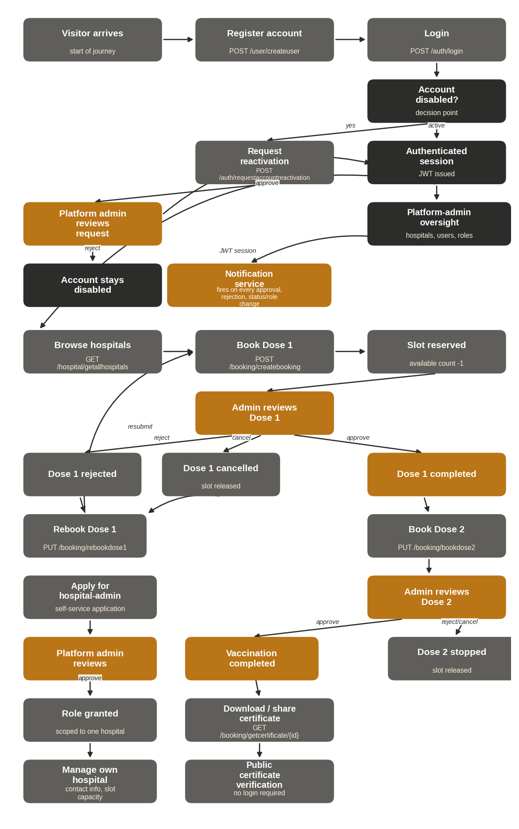
Figure 1. End-to-end functional flow — registration through certificate, with hospital-admin and platform-admin oversight paths.

3.4 Technology Snapshot
Provided here for orientation only — full detail is in the companion Technical Specification document.
LAYER | TECHNOLOGY
Runtime & Framework | .NET 10 / ASP.NET Core Web API
Data Access | Entity Framework Core 10 over Microsoft SQL Server
Authentication | JWT Bearer (HMAC-SHA256), server-side revocation list for logout
Password Security | BCrypt hashing — plain text is never persisted
Frontend | Angular 20 (standalone components) with TailwindCSS

4. User Roles & Access Model

4.1 Role Definitions
ROLE | DEFINITION
Normal User | The default role granted on registration. Full control over their own profile and their own booking; no visibility into other users' data.
Hospital Admin | A normal user additionally granted the hospital-admin scoped role for exactly one hospital (via direct admin assignment or an approved self-service application). Can manage that hospital's contact details, slot capacity, and dose approvals — and nothing outside that scope.
Platform Admin | A user with the platform-wide admin flag. Unconditional access across every module: user and hospital lifecycle management, all bookings, all role assignments, and every pending request queue.

4.2 Role Assignment Mechanism
The system uses two independent, layered role mechanisms:
- Platform role — a boolean flag on the user's account, baked into the JWT at login as the admin claim. Checked declaratively at the endpoint level ([Authorize(Roles = "admin")]).
- Scoped role — a row in the role-mapping table keyed by user, role tag, and a context id (a Hospital Id for hospital-admin). Checked at runtime, inside the service layer, against the specific entity being acted on — so a hospital admin for Hospital A is transparently rejected when attempting to act on Hospital B.
A platform admin unconditionally satisfies any scoped-role check without a database lookup. A user may hold the hospital-admin scoped role for more than one hospital simultaneously, via multiple independent role-mapping rows.

4.3 Roles & Permissions Matrix
CAPABILITY | NORMAL USER | HOSPITAL ADMIN | PLATFORM ADMIN
Register, login/logout, forgot/reset password | Y | Y | Y
Manage own profile, email, password | Y | Y | Y
Delete own account | Y | Y | Y
Book / edit / rebook / cancel own doses | Y | Y | Y
View/download own certificate | Y | Y | Y
Apply for hospital-admin role | Y | Y | —
View all hospitals / a hospital's own profile | Y | Y | Y
Update hospital contact info / slot capacity | N | Own hosp. | Y
Approve / reject a dose | N | Own hosp. | Y
View bookings for a hospital | Y | Y | Y
View all bookings platform-wide | N | N | Y
Admin-override a booking (all fields) / delete a booking | N | N | Y
Disable / reactivate / unregister a hospital | N | Request only* | Y
Create a hospital | N | N | Y
View / manage all users, promote / demote admin | N | N | Y
Disable / reactivate a user account | N | N | Y
Assign / revoke scoped roles, review pending requests | N | N | Y
* A hospital admin may request reactivation, decline an unregister request, or authorize a pending unregister for their own hospital — but cannot initiate a disable or unregister; only a platform admin can.

4.4 Use Case Diagrams
The following four diagrams present the system's use cases grouped by functional package (a standard UML practice when the combined actor/use-case count is too large for a single legible diagram), rather than as one combined diagram.
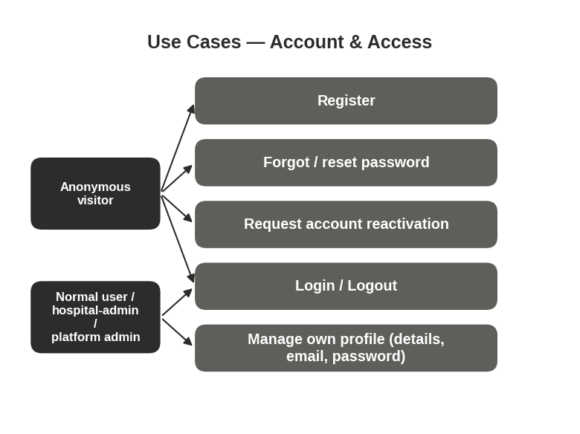
Figure 2. Use cases — Account & Access.
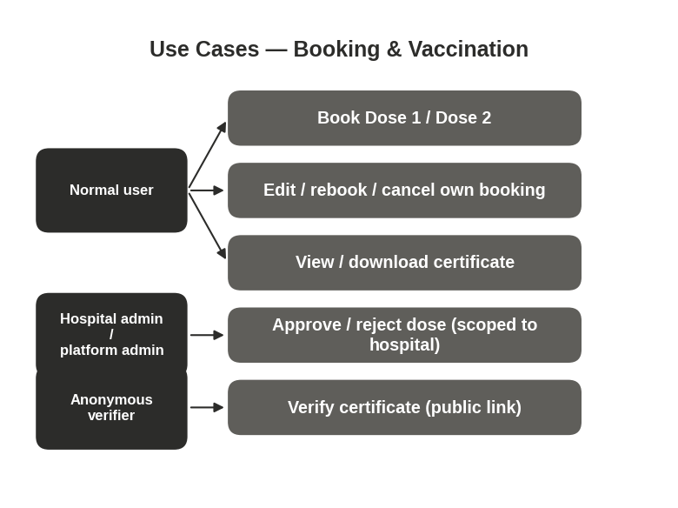
Figure 3. Use cases — Booking & Vaccination.

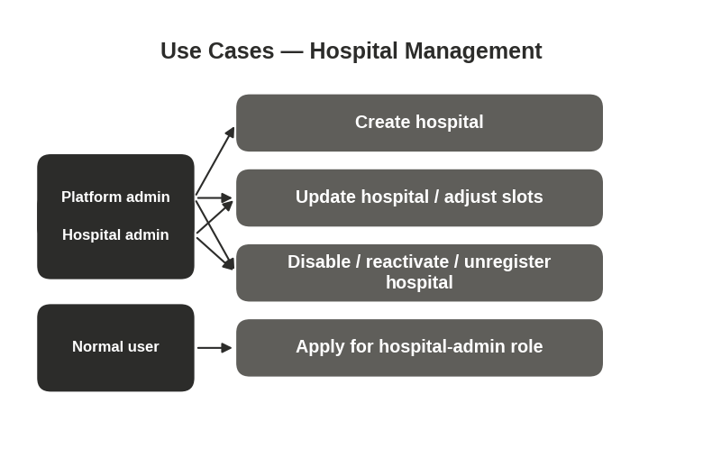
Figure 4. Use cases — Hospital Management.
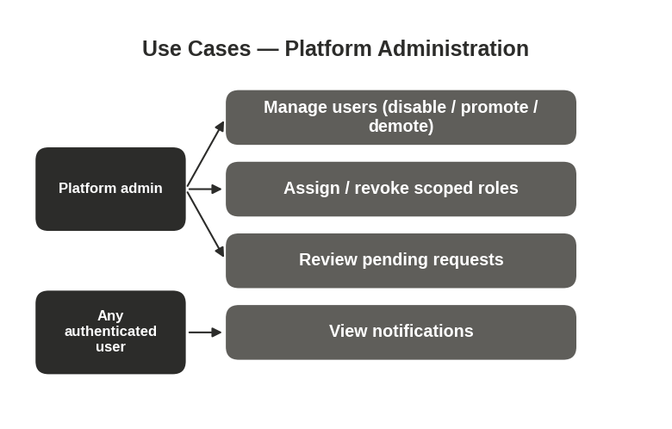
Figure 5. Use cases — Platform Administration.

5. Functional Requirements
This section specifies every endpoint the platform exposes, grouped into the six functional modules introduced in Section 3.1. Each module opens with an overview, its High-Level Design (component) diagram, a Low-Level Design (decision-flow) diagram, a summary of its key operational flows, a state diagram where the module owns an entity lifecycle, and one requirement card per endpoint.

5.1 Module: Authentication & Account Access
Auth
Login, logout, password recovery, and the disabled-account reactivation path
This module is the single entry and exit point for authentication. It issues and revokes JWTs, and owns the two self-service recovery paths a user needs when they cannot log in: a forgotten password, and a disabled account. It deliberately returns identical, generic responses for any credential failure (wrong password, unknown email, or a soft-deleted account) to prevent account enumeration — see BR-19.
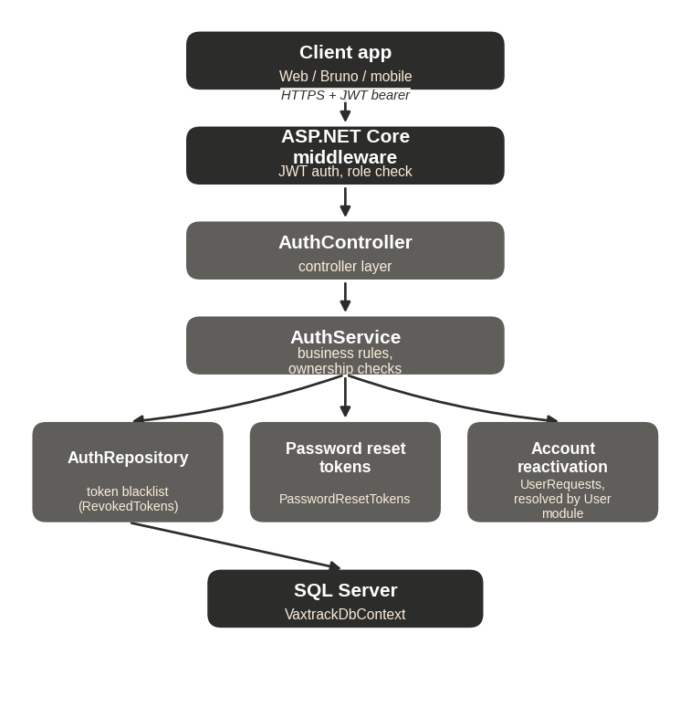
Figure 6. High-Level Design — Auth module.
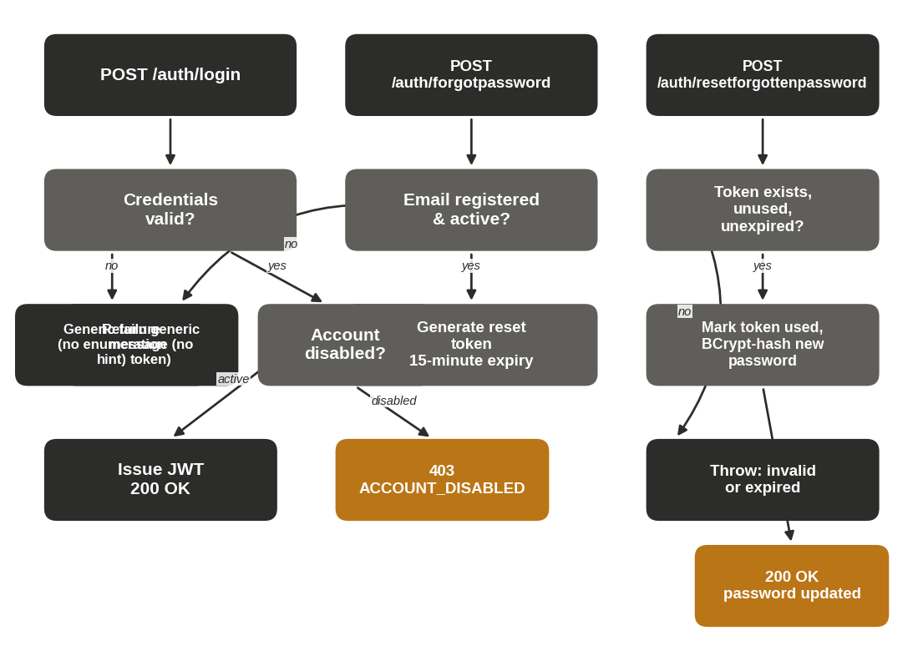
Figure 7. Low-Level Design — login and password-recovery decision flow.

Key Flow — User Registration (Figure 8)
1. Visitor submits POST /user/createuser with profile, email, and password.
2. UserService checks whether the email already belongs to an active account; if so, registration fails.
3. If the email is available, the system generates a UserUid/UserId, computes age at registration, and inserts the new UserModel with role = user.
4. The password is BCrypt-hashed and stored as UserCredentials.
5. A 201 Created response returns the new user's profile summary.

Key Flow — Login, Including the Disabled-Account Block (Figure 9)
1. User submits POST /auth/login with email and password.
2. AuthService looks up credentials by email; if not found or the password does not match, a generic failure is returned (no enumeration hint).
3. If credentials are valid, the account status is checked. A Disabled account throws AccountDisabledException, surfaced as 403 ACCOUNT_DISABLED with a reason — the user's only path forward is to submit a reactivation request.
4. An Active account receives a signed JWT (claims: user id, email, name, role, unique token id) and a 200 OK LoginResponseDto.

Key Flow — Forgot Password / Reset Password (Figure 10)
1. User submits POST /auth/forgotpassword with their email (not logged in).
2. If the email is not registered or has been deleted, a generic acknowledgement is returned with no token generated — this shape is identical to the success case, preventing enumeration.
3. If the email is active, a 32-character single-use token is generated with a 15-minute expiry and stored in PasswordResetTokens.
4. User submits POST /auth/resetforgottenpassword with the token and a new password.
5. The token is validated (must exist, be unused, and be unexpired); an invalid or expired token is rejected.
6. On success, the token is marked used, the new password is BCrypt-hashed, and UserCredentials.PasswordHash is updated.

Key Flow — Account Reactivation Request and Approval (Figure 11)
1. A disabled user submits POST /auth/requestaccountreactivation with an email and optional reason.
2. The system inserts a UserRequest (RequestType = AccountReactivation) and notifies all platform admins in-app.
3. A platform admin reviews the pending-requests queue and calls PUT /user/approveuserreactivation/{userId} (or the reject equivalent).
4. On approval, UserModel.Status is set back to Active, the UserRequest is marked Approved, and the user is notified that they can log in again.

Endpoint Requirements
FR-AUTH-01 — Login POST
FIELD | DETAIL
Endpoint | POST /api/vaxtrack/v1/auth/login
Actor | Anonymous
Behaviour: Verifies email + password against stored credentials, confirms the account is not soft-deleted or Disabled, and issues a signed JWT (claims: user id, email, name, role, unique token id) with a configured expiry.
Business Rules: BR-19 (no enumeration), BR-20 (disabled accounts blocked post-verification), BR-24 (BCrypt only).
Error Cases: Wrong password or unknown email → generic failure. Disabled account → 403 ACCOUNT_DISABLED with reason (only after password is verified).
FR-AUTH-02 — Logout POST
FIELD | DETAIL
Endpoint | POST /api/vaxtrack/v1/auth/logout
Actor | Any authenticated user
Behaviour: Extracts the token's unique id and expiry from the already-validated request and records it as revoked. Every subsequent authenticated request is checked against this revocation list before it reaches a controller, so the token becomes unusable immediately — even though JWTs are otherwise stateless.
Business Rules: BR-25 (server-side revocation on logout).
FR-AUTH-03 — Forgot Password POST
FIELD | DETAIL
Endpoint | POST /api/vaxtrack/v1/auth/forgotpassword
Actor | Anonymous
Behaviour: Step 1 of the recovery flow. Issues a single-use reset token with a 15-minute expiry when the email belongs to an active account. Returns the same generic acknowledgement whether or not the email is registered.
Business Rules: BR-19, BR-21 (15-minute single-use token).
FR-AUTH-04 — Reset Forgotten Password POST
FIELD | DETAIL
Endpoint | POST /api/vaxtrack/v1/auth/resetforgottenpassword
Actor | Anonymous
Behaviour: Step 2 of the recovery flow. Validates the reset token (must exist, be unused, and be unexpired), marks it used, then hashes and stores the new password.
Business Rules: BR-21, BR-24.
Error Cases: Invalid, expired, or already-used token → rejected.
FR-AUTH-05 — Request Account Reactivation POST
FIELD | DETAIL
Endpoint | POST /api/vaxtrack/v1/auth/requestaccountreactivation
Actor | Anonymous (a disabled account cannot log in to reach any other path)
Behaviour: The only route back for a disabled account. Records a pending reactivation request (with an optional reason) for a platform admin to review; see FR-USER-13/14 for the approval path.
Business Rules: BR-20, BR-26 (every disable/reactivation decision requires a platform admin).

5.2 Module: User Management
User
Registration, self-service profile management, and the full user lifecycle
This module owns the user's identity and profile data, self-service account management (email, password, profile picture, self-delete), the platform admin's full user-management toolkit (paged directory, disable/reactivate, promote/demote, hard admin delete), and the user account status lifecycle. Every mutating endpoint enforces an ownership check in the service layer: a caller must either own the target account or hold the platform admin role.
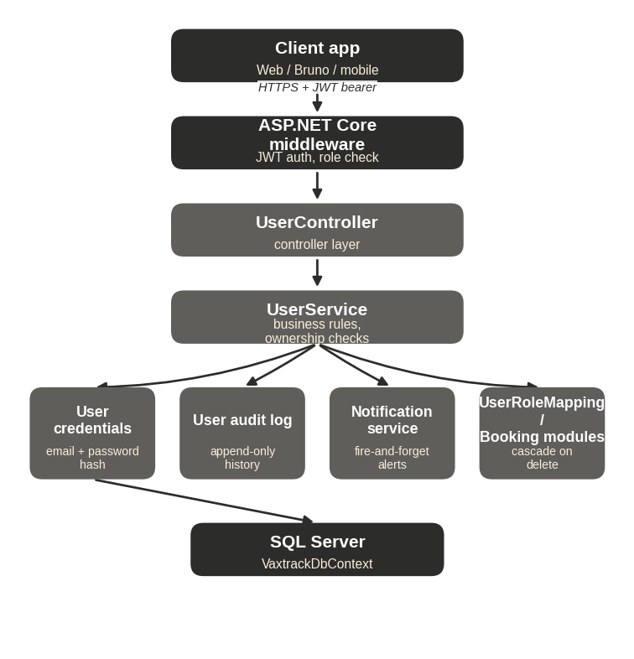
Figure 12. High-Level Design — User module.
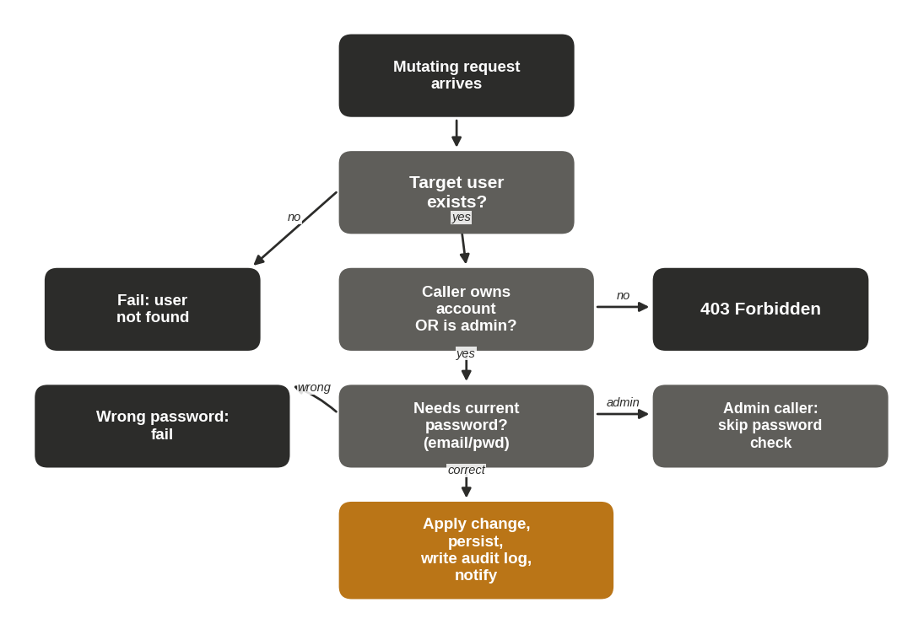
Figure 13. Low-Level Design — ownership and authorization decision flow for mutating requests.

Key Flow — Self-Service Profile, Email, and Password Updates (Figure 14)
1. User calls PUT /user/updateuser, updateemail, or changepassword. The caller's identity and admin flag are extracted from the JWT.
2. UserService loads the target user and checks that the caller either owns the account or is a platform admin; otherwise it throws UnauthorizedAccessException, surfaced as 403 Forbidden.
3. For an email or password change by a non-admin caller, the current password must be verified via BCrypt before the change is applied.
4. The change is persisted and a 200 OK response is returned with the updated profile.
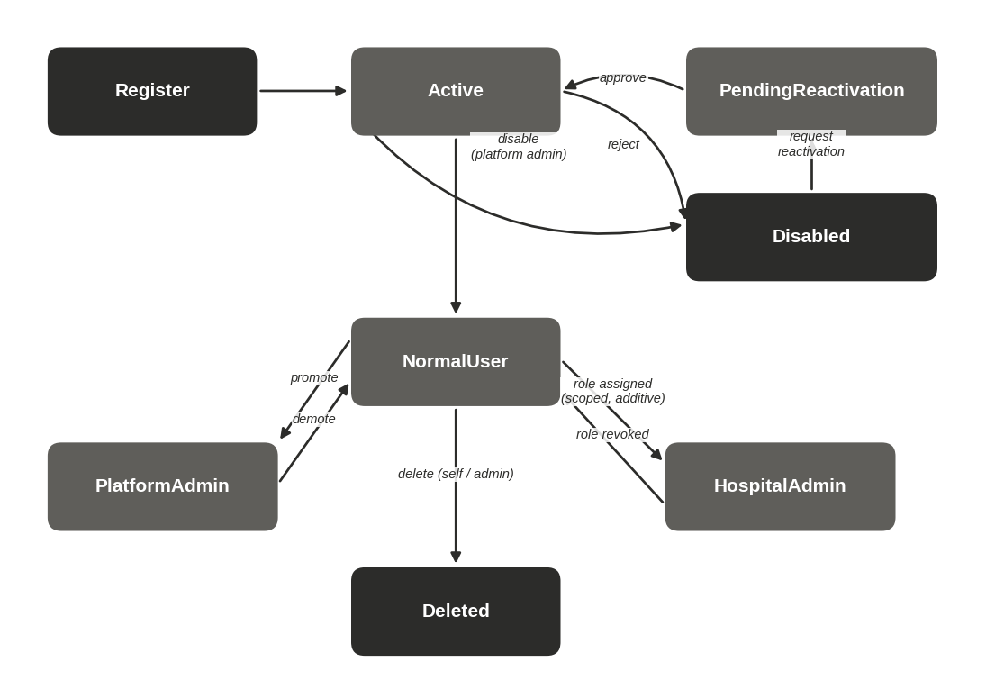
Figure 15. State diagram — user account lifecycle and platform-role transitions.

Endpoint Requirements
FR-USER-01 — Create User (Registration) POST
FIELD | DETAIL
Endpoint | POST /api/vaxtrack/v1/user/createuser
Actor | Anonymous
Behaviour: Registers a new normal user. Validates the birthdate is in the past, rejects an email already in active use, computes age at registration, and stores a BCrypt password hash.
Business Rules: BR-16, BR-14, BR-24.
FR-USER-02 — Update User PUT
FIELD | DETAIL
Endpoint | PUT /api/vaxtrack/v1/user/updateuser
Actor | Owner or platform admin
Behaviour: Updates mutable profile fields (name, gender, phone, address, pin code, profile picture path). Identity fields (UserId, UserUid, birthdate, age, role, email) are immutable through this endpoint.
Error Cases: Caller does not own the account and is not admin → 403.
FR-USER-03 — Update Email PUT
FIELD | DETAIL
Endpoint | PUT /api/vaxtrack/v1/user/updateemail
Actor | Owner or platform admin
Behaviour: Non-admin callers must supply their current password; admins may override without it (support/recovery use case). New email must not already belong to another active account.
Business Rules: BR-14, BR-15.
FR-USER-04 — Change Password PUT
FIELD | DETAIL
Endpoint | PUT /api/vaxtrack/v1/user/changepassword
Actor | Owner or platform admin
Behaviour: Same non-admin-password-required pattern as Update Email. Distinct from the anonymous forgot-password flow — this requires an active session.
Business Rules: BR-15, BR-24.
FR-USER-05 — Upload Profile Picture POST
FIELD | DETAIL
Endpoint | POST /api/vaxtrack/v1/user/uploadprofilepicture
Actor | Owner or platform admin
Behaviour: Accepts a multipart file upload and stores the resulting path against the user's profile.
FR-USER-06 — Remove Profile Picture PUT
FIELD | DETAIL
Endpoint | PUT /api/vaxtrack/v1/user/removeprofilepicture/{userId}
Actor | Owner or platform admin
Behaviour: Clears the stored profile picture path.
FR-USER-07 — Get All Users GET
FIELD | DETAIL
Endpoint | GET /api/vaxtrack/v1/user/getallusers
Actor | Platform admin only
Behaviour: Returns the full user directory. Superseded operationally by the paged variant (FR-USER-08) for the Users Management screen.
FR-USER-08 — Get Users (Paged & Filtered) GET
FIELD | DETAIL
Endpoint | GET /api/vaxtrack/v1/user/getuserspaged
Actor | Platform admin only
Behaviour: Filterable by name, phone, user id/uid, role, and vaccination status; sortable; paginated. Backs the platform admin's Users Management screen.
FR-USER-09 — Get User Profile Data GET
FIELD | DETAIL
Endpoint | GET /api/vaxtrack/v1/user/getuserprofiledata/{userId}
Actor | Owner or platform admin
Behaviour: Returns the full profile, including hospital-admin flag, vaccination status, and account status. A non-owner, non-admin caller is rejected — this prevents PII harvesting.
FR-USER-10 — Delete My Account DELETE
FIELD | DETAIL
Endpoint | DELETE /api/vaxtrack/v1/user/deletemyaccount
Actor | Any authenticated user (self only)
Behaviour: Requires the caller's current password. Identity comes from the JWT, not a URL parameter. Cascades: soft-deletes the user, soft-deletes their active bookings (releasing any reserved slots), revokes all role mappings, and soft-deletes their credentials (freeing the email for reuse).
Business Rules: BR-12, BR-14.
FR-USER-11 — Delete User (Admin) DELETE
FIELD | DETAIL
Endpoint | DELETE /api/vaxtrack/v1/user/deleteuser/{userId}
Actor | Platform admin only
Behaviour: Same cascade as Delete My Account, targeting any user by id.
Business Rules: BR-12.
FR-USER-12 — Disable User PUT
FIELD | DETAIL
Endpoint | PUT /api/vaxtrack/v1/user/disableuser/{userId}
Actor | Platform admin only
Behaviour: Sets the account to Disabled with a mandatory reason. Blocks all future login attempts (Section 5.1, FR-AUTH-01) until reactivated.
Business Rules: BR-20, BR-26.
FR-USER-13 — Approve User Reactivation PUT
FIELD | DETAIL
Endpoint | PUT /api/vaxtrack/v1/user/approveuserreactivation/{userId}
Actor | Platform admin only
Behaviour: Resolves a pending reactivation request (see FR-AUTH-05) by restoring the account to Active.
FR-USER-14 — Reject User Reactivation PUT
FIELD | DETAIL
Endpoint | PUT /api/vaxtrack/v1/user/rejectuserreactivation/{userId}
Actor | Platform admin only
Behaviour: Resolves a pending reactivation request by keeping the account Disabled, with an optional comment.
FR-USER-15 — Promote to Admin PUT
FIELD | DETAIL
Endpoint | PUT /api/vaxtrack/v1/user/promotetoadmin/{userId}
Actor | Platform admin only
Behaviour: Grants the platform-wide admin flag to the target user.
FR-USER-16 — Demote from Admin PUT
FIELD | DETAIL
Endpoint | PUT /api/vaxtrack/v1/user/demotefromadmin/{userId}
Actor | Platform admin only
Behaviour: Revokes the platform-wide admin flag from the target user, returning them to normal-user privileges (any scoped hospital-admin roles they separately hold are unaffected).

5.3 Module: Hospital Management
Hospital
Hospital directory, slot capacity, and the disable / reactivate / unregister lifecycle
This module owns each hospital's profile, its slot capacity, and its operational status. Contact-info and capacity changes are available to a platform admin or to that hospital's own scoped hospital-admin — a hospital-admin for one hospital has no visibility into changing another's data. Permanently removing a hospital is deliberately a two-party process: a platform admin initiates it, and the hospital's own admin must separately re-authenticate to authorize it (or decline it) — see BR-11 and Figure 20.
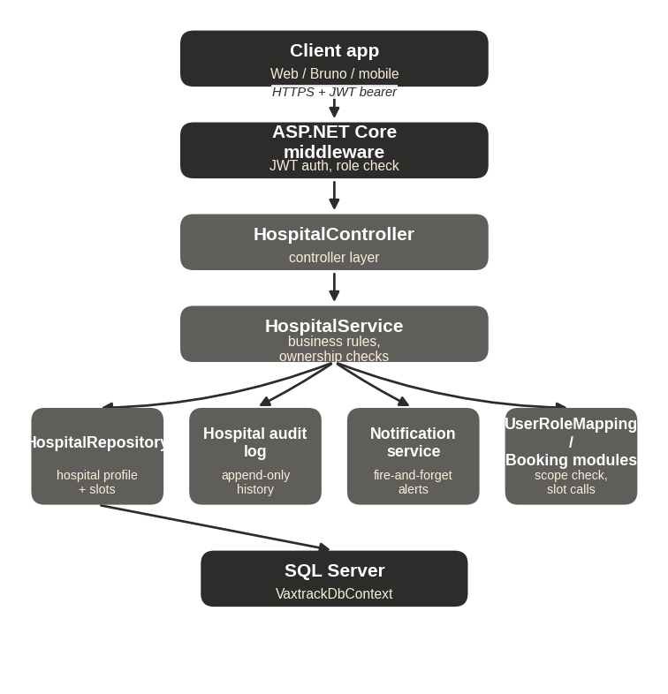
Figure 16. High-Level Design — Hospital module.
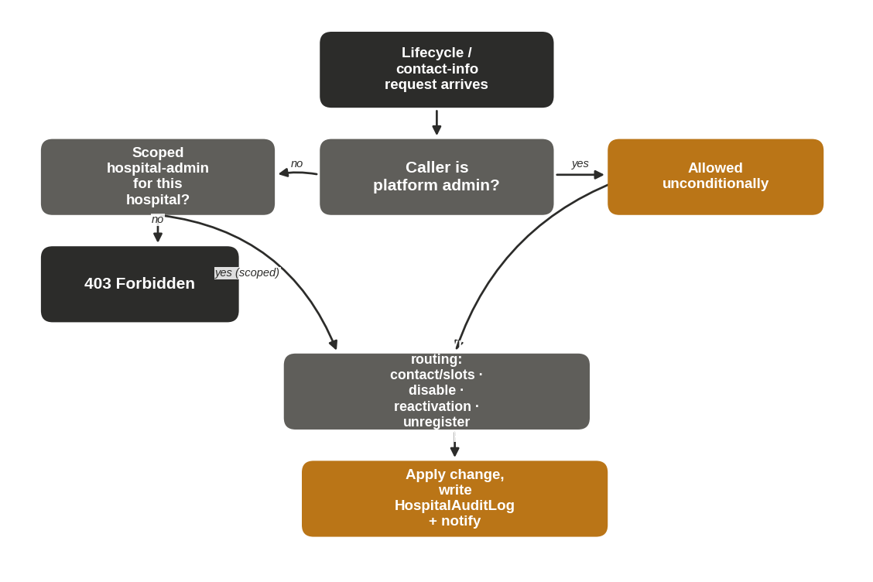
Figure 17. Low-Level Design — hospital-admin scope check and lifecycle action routing.

Key Flow — Create Hospital and Scoped Contact-Info Update (Figure 18)
1. Platform admin submits POST /hospital/createhospital with a hospital name.
2. The system generates a HospitalId/HospitalUid and inserts the hospital with default capacity (TotalSlots = SlotsAvailable = 50).
3. A hospital admin later submits PUT /hospital/updatehospital with contact fields.
4. HospitalService checks whether the caller is scoped to this hospital via IsUserInRoleAsync; if not, it throws UnauthorizedAccessException (403 Forbidden).
5. If scoped correctly, the contact fields are updated and a 200 OK response is returned.

Key Flow — Disable and Reactivation-Request Lifecycle (Figure 19)
1. Platform admin submits PUT /hospital/disablehospital/{id} with a mandatory reason; status becomes Disabled and the hospital's admin is notified.
2. The hospital's own hospital-admin submits PUT /hospital/requestreactivation/{id}; all platform admins are notified of the pending request.
3. A platform admin submits PUT /hospital/approvereactivation/{id}; status returns to Active and the hospital-admin is notified.

Key Flow — Two-Party Unregister Confirmation (Figure 20)
1. Platform admin submits PUT /hospital/requestunregister/{id} with a reason; status becomes PendingUnregister and a notification is fired.
2. The hospital's own hospital-admin may decline (PUT /hospital/declineunregisterrequest/{id}), reverting status to Active, or the initiating platform admin may withdraw the request (PUT /hospital/withdrawunregisterrequest/{id}), also reverting to Active.
3. Alternatively, the hospital-admin authorizes the unregister via PUT /hospital/authorizeunregister/{id}, re-entering their own login password as a second-party confirmation.
4. If the password is wrong, the request fails with 400 Bad Request. If correct, the hospital is soft-deleted and every role mapping scoped to it is revoked (204 No Content).
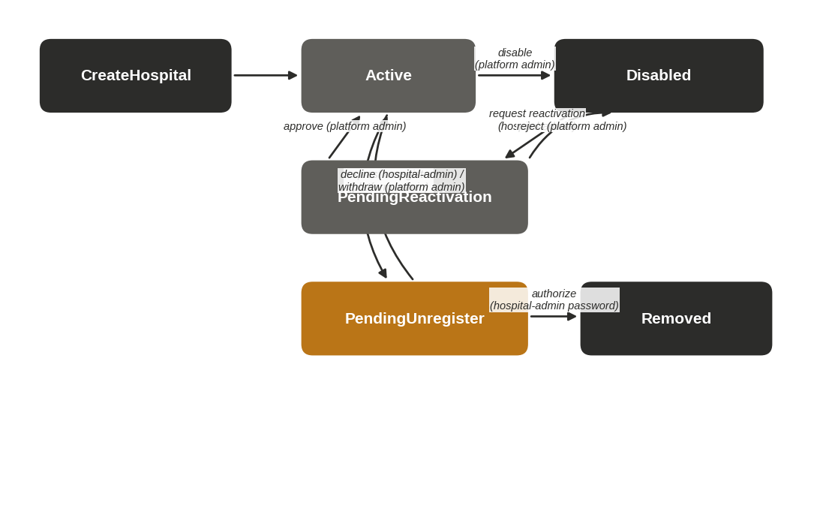
Figure 21. State diagram — hospital operational status lifecycle.

Endpoint Requirements
FR-HOSP-01 — Create Hospital POST
FIELD | DETAIL
Endpoint | POST /api/vaxtrack/v1/hospital/createhospital
Actor | Platform admin only
Behaviour: Registers a new hospital with a default capacity of 50 total / 50 available slots. Contact fields start empty and are filled in via Update Hospital.
FR-HOSP-02 — Update Hospital PUT
FIELD | DETAIL
Endpoint | PUT /api/vaxtrack/v1/hospital/updatehospital
Actor | Platform admin or that hospital's scoped hospital-admin
Behaviour: Updates address, pin code, phone, and email. Name, id, and slot fields are immutable through this endpoint.
Business Rules: BR-07, BR-08.
FR-HOSP-03 — Update Total Slots PUT
FIELD | DETAIL
Endpoint | PUT /api/vaxtrack/v1/hospital/updatetotalslots/{hospitalId}/{totalSlots}
Actor | Platform admin or scoped hospital-admin
Behaviour: Sets the hospital's maximum capacity. If the new total falls below the current available count, available is clamped down to match — available can never exceed total.
Business Rules: BR-08.
FR-HOSP-04 — Update Available Slots PUT
FIELD | DETAIL
Endpoint | PUT /api/vaxtrack/v1/hospital/updateavailableslots/{hospitalId}/{slotsToUpdate}
Actor | Platform admin, scoped hospital-admin, or the Booking module internally
Behaviour: Applies a signed delta to the available count (e.g. -1 to reserve, +1 to release). Rejects any change that would push available below zero or above total. Called internally by the Booking module on every reserve/release — those internal calls bypass the human authorization check.
Business Rules: BR-08.
FR-HOSP-05 — Get Hospital By Id GET
FIELD | DETAIL
Endpoint | GET /api/vaxtrack/v1/hospital/gethospitalbyid/{hospitalId}
Actor | Any authenticated user
FR-HOSP-06 — Get All Hospitals GET
FIELD | DETAIL
Endpoint | GET /api/vaxtrack/v1/hospital/getallhospitals
Actor | Any authenticated user
FR-HOSP-07 — Disable Hospital PUT
FIELD | DETAIL
Endpoint | PUT /api/vaxtrack/v1/hospital/disablehospital/{hospitalId}
Actor | Platform admin only
Behaviour: Sets status to Disabled with a mandatory reason.
Business Rules: BR-26.
FR-HOSP-08 — Request Reactivation PUT
FIELD | DETAIL
Endpoint | PUT /api/vaxtrack/v1/hospital/requestreactivation/{hospitalId}
Actor | That hospital's own scoped hospital-admin
FR-HOSP-09 — Approve / Reject Reactivation PUT
FIELD | DETAIL
Endpoint | PUT /api/vaxtrack/v1/hospital/approvereactivation/{hospitalId} | PUT /.../rejectreactivation/{hospitalId}
Actor | Platform admin only
Behaviour: Resolves a pending reactivation request — approve restores Active status, reject keeps the hospital Disabled.
FR-HOSP-10 — Request Unregister PUT
FIELD | DETAIL
Endpoint | PUT /api/vaxtrack/v1/hospital/requestunregister/{hospitalId}
Actor | Platform admin only
Behaviour: Moves the hospital to PendingUnregister with a mandatory reason. Does not remove the hospital by itself — see FR-HOSP-13.
Business Rules: BR-11.
FR-HOSP-11 — Withdraw Unregister Request PUT
FIELD | DETAIL
Endpoint | PUT /api/vaxtrack/v1/hospital/withdrawunregisterrequest/{hospitalId}
Actor | Platform admin only
Behaviour: The initiating platform admin reverses their own pending unregister request, restoring Active status.
FR-HOSP-12 — Decline Unregister Request PUT
FIELD | DETAIL
Endpoint | PUT /api/vaxtrack/v1/hospital/declineunregisterrequest/{hospitalId}
Actor | That hospital's own scoped hospital-admin
Behaviour: The hospital's own admin pushes back on a pending unregister, restoring Active status.
FR-HOSP-13 — Authorize Unregister PUT
FIELD | DETAIL
Endpoint | PUT /api/vaxtrack/v1/hospital/authorizeunregister/{hospitalId}
Actor | That hospital's own scoped hospital-admin (or the platform admin if no hospital-admin is assigned)
Behaviour: The second-party confirmation step. The caller re-enters their own login password; on success the hospital is permanently removed (soft-deleted) and every role mapping scoped to it is revoked.
Business Rules: BR-11.
Error Cases: Wrong password → 400 Bad Request.
FR-HOSP-14 — Get Hospital Audit Trail GET
FIELD | DETAIL
Endpoint | GET /api/vaxtrack/v1/hospital/gethospitalaudittrail/{hospitalId}
Actor | Platform admin or that hospital's scoped hospital-admin
Behaviour: Returns the full, permanent history of lifecycle actions taken against this hospital — actor, action type, comment, and timestamp for each.

5.4 Module: Booking & Vaccination Lifecycle
Booking
The two-dose booking journey, approvals, cancellations, audit trail, and certificates
This is the platform's core module: one booking record tracks a single beneficiary's Dose 1 and Dose 2 journey from request through completion, cancellation, or rejection. Every dose-level action is ownership- or role-checked, slot capacity is reserved and released automatically via the Hospital module, and every action is written to a permanent audit trail. A completed vaccination produces a public, unauthenticated certificate that mirrors how a real vaccination QR code works.
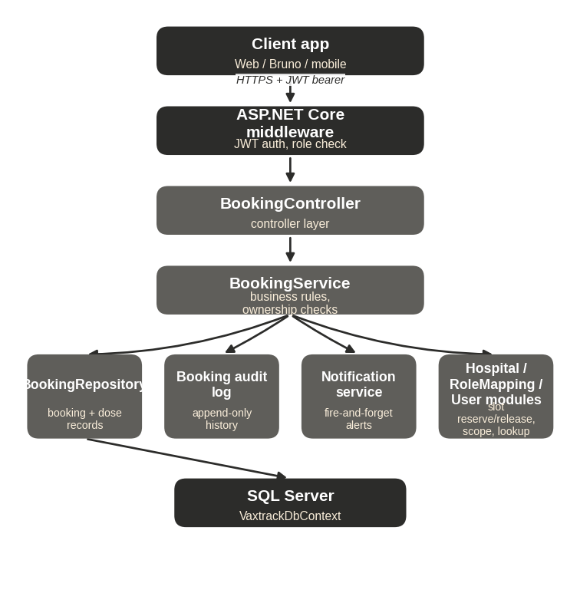
Figure 22. High-Level Design — Booking module.
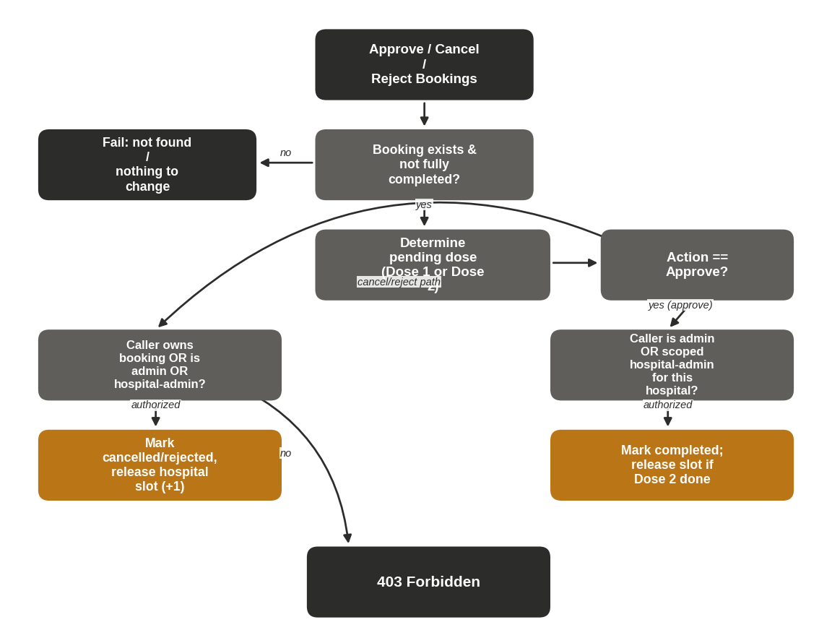
Figure 23. Low-Level Design — approve/cancel/reject decision flow.

Key Flow — Create Dose 1 Booking and Approval (Figure 24)
1. User submits POST /booking/createbooking with their own UserUid, a hospital, and a date; the caller's identity must match dto.UserUid or the request is rejected as impersonation.
2. BookingService checks the caller has no existing active booking and the target hospital has available capacity, then inserts the booking with Dose 1 pending and reserves one slot (-1 available).
3. A hospital admin or platform admin scoped to that hospital submits PUT /booking/approvebookings/{bookingId}; Dose 1 is marked completed with a timestamp and the user is notified.

Key Flow — Dose 2 Booking Through Completion and Certificate (Figure 25)
1. Once Dose 1 is completed, the user submits PUT /booking/bookdose2 with a hospital and date (which may differ from Dose 1's hospital); the slot is reserved.
2. The reviewing admin approves via PUT /booking/approvebookings/{bookingId}; Dose 2 and the whole booking are marked vaccination-completed, and the user is notified.
3. The user (or anyone with the link) calls GET /booking/getcertificate/{bookingId} to retrieve the certificate — name, age, gender, dates, and hospitals.

Key Flow — Cancel, Reject, Edit, and Rebook Variants (Figure 26)
1. User cancels a pending dose via PUT /booking/cancelbookings/{id}; the relevant dose is marked cancelled and its reserved slot is released.
2. An admin or hospital-admin instead rejects a pending dose via PUT /booking/rejectbookings/{id} — distinct from a user cancel for audit-trail clarity — releasing the slot the same way.
3. A user may move an unapproved dose to a new hospital/date via PUT /booking/editbooking without cancelling and recreating the booking.
4. A user may reopen a cancelled or rejected Dose 1 via PUT /booking/rebookdose1, re-entering pending status on a new hospital/date.

Key Flow — Certificate Download and Public Verification (Figure 27)
1. A vaccinated user retrieves their own certificate while logged in via GET /booking/getcertificate/{bookingId}, and may share the link.
2. Anyone with the link — no login required — can hit the same endpoint (AllowAnonymous). If the booking is not found or vaccination is not yet complete, the response is 404 Not Found.
3. If vaccination is complete, the certificate is returned without exposing email, phone, or address — mirroring a real QR-code verification.
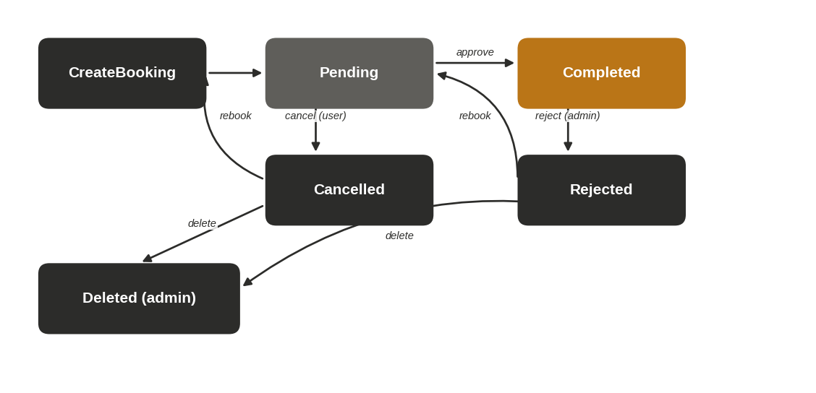
Figure 28. State diagram — Dose 1 lifecycle.
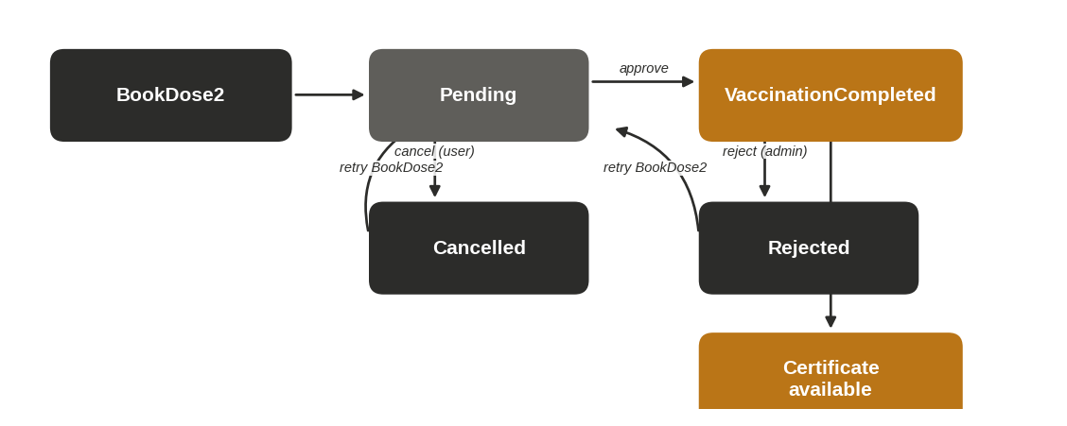
Figure 29. State diagram — Dose 2 and vaccination completion.

Endpoint Requirements
FR-BOOK-01 — Create Booking (Book Dose 1) POST
FIELD | DETAIL
Endpoint | POST /api/vaxtrack/v1/booking/createbooking
Actor | Any authenticated user (self only)
Behaviour: Verifies the target user matches the caller, the requested date is in the future, the caller has no existing active booking, and the hospital has capacity — then creates the booking and reserves one slot.
Business Rules: BR-01, BR-02, BR-13.
Error Cases: Impersonation attempt → 403. Past date, duplicate booking, or no capacity → rejected.
FR-BOOK-02 — Update Booking (Admin Override) PUT
FIELD | DETAIL
Endpoint | PUT /api/vaxtrack/v1/booking/updatebooking
Actor | Platform admin only
Behaviour: Full-field override, including dose-completion flags and timestamps — used for manual data correction. Deliberately restricted to platform admin since it can mark a dose "completed" without the normal approval path.
Business Rules: BR-09.
FR-BOOK-03 — Book Dose 2 PUT
FIELD | DETAIL
Endpoint | PUT /api/vaxtrack/v1/booking/bookdose2
Actor | Booking owner
Behaviour: Only permitted once Dose 1 is completed and Dose 2 has not already been booked. Dose 2 may be at a different hospital than Dose 1.
Business Rules: BR-03, BR-04.
FR-BOOK-04 — Edit Booking PUT
FIELD | DETAIL
Endpoint | PUT /api/vaxtrack/v1/booking/editbooking
Actor | Booking owner
Behaviour: Moves an unapproved dose (1 or 2) to a new hospital and/or date without cancelling and recreating the booking.
FR-BOOK-05 — Rebook Dose 1 PUT
FIELD | DETAIL
Endpoint | PUT /api/vaxtrack/v1/booking/rebookdose1
Actor | Booking owner
Behaviour: Re-opens Dose 1 as pending on a new hospital/date after it was cancelled or rejected, rather than requiring a brand-new booking record.
FR-BOOK-06 — Approve Bookings PUT
FIELD | DETAIL
Endpoint | PUT /api/vaxtrack/v1/booking/approvebookings/{bookingId}
Actor | Platform admin, or scoped hospital-admin for the pending dose's hospital
Behaviour: Determines whichever dose is currently pending and marks it completed with a timestamp. Approving Dose 2 also marks the whole booking as vaccination-completed.
Business Rules: BR-03, BR-07.
Error Cases: Already fully vaccinated, or no pending dose → rejected. Wrong-hospital hospital-admin → 403.
FR-BOOK-07 — Cancel Bookings PUT
FIELD | DETAIL
Endpoint | PUT /api/vaxtrack/v1/booking/cancelbookings/{bookingId}
Actor | Booking owner or platform admin
Behaviour: Cancels whichever dose is currently pending and releases its reserved slot. A completed dose can never be cancelled.
Business Rules: BR-05, BR-06.
FR-BOOK-08 — Reject Bookings PUT
FIELD | DETAIL
Endpoint | PUT /api/vaxtrack/v1/booking/rejectbookings/{bookingId}
Actor | Platform admin or scoped hospital-admin
Behaviour: Administratively rejects the pending dose (distinct from a user-initiated cancel, for audit-trail clarity) and releases the slot.
Business Rules: BR-06, BR-07.
FR-BOOK-09 — Get Booking Audit Trail GET
FIELD | DETAIL
Endpoint | GET /api/vaxtrack/v1/booking/getbookingaudittrail/{bookingId}
Actor | Booking owner or platform admin
Behaviour: Returns the permanent history of every action taken on this booking — dose number, action type, actor, role, comment, and timestamp.
FR-BOOK-10 — Get Actionable Bookings GET
FIELD | DETAIL
Endpoint | GET /api/vaxtrack/v1/booking/getactionablebookings
Actor | Any authenticated user
Behaviour: Bookings still needing action, scoped internally to the caller's own hospital-admin assignment(s), or all such bookings for a platform admin. A caller with no assignment simply receives an empty list.
FR-BOOK-11 — Get Booking By Id GET
FIELD | DETAIL
Endpoint | GET /api/vaxtrack/v1/booking/getbookingbybookingid/{bookingId}
Actor | Booking owner or platform admin
FR-BOOK-12 — Get Bookings By User GET
FIELD | DETAIL
Endpoint | GET /api/vaxtrack/v1/booking/getbookingsbyuserid/{userId}
Actor | That user or platform admin
FR-BOOK-13 — Get Bookings By Hospital GET
FIELD | DETAIL
Endpoint | GET /api/vaxtrack/v1/booking/getbookingsbyhospitalid/{hospitalId}
Actor | Any authenticated user
FR-BOOK-14 — Get All Bookings GET
FIELD | DETAIL
Endpoint | GET /api/vaxtrack/v1/booking/getallbookings
Actor | Platform admin only
FR-BOOK-15 — Get Next Available Slot GET
FIELD | DETAIL
Endpoint | GET /api/vaxtrack/v1/booking/getnextavailableslot/{hospitalId}/{date}
Actor | Any authenticated user
Behaviour: Read-only preview of the slot that would be assigned for a given hospital and date, shown to the user before they submit a booking.
FR-BOOK-16 — Is Booking Exists GET
FIELD | DETAIL
Endpoint | GET /api/vaxtrack/v1/booking/isbookingexists/{bookingId}
Actor | Any authenticated user
FR-BOOK-17 — Delete Booking DELETE
FIELD | DETAIL
Endpoint | DELETE /api/vaxtrack/v1/booking/deletebooking/{bookingId}
Actor | Platform admin only
Behaviour: Soft-deletes the booking and releases any dose still pending (neither completed nor already cancelled/rejected) back to hospital capacity.
FR-BOOK-18 — Get Certificate GET
FIELD | DETAIL
Endpoint | GET /api/vaxtrack/v1/booking/getcertificate/{bookingId}
Actor | Anonymous (public)
Behaviour: Public, unauthenticated lookup by booking id — mirrors a real vaccination certificate's QR-code verification. Returns beneficiary name, age, gender, both hospitals, and completion dates; deliberately excludes email, phone, and address.
Business Rules: BR-22.
Error Cases: Booking not found or vaccination not yet complete → 404.

5.5 Module: Role & Access Requests
UserRoleMapping
Scoped role assignment and the hospital-admin self-service application queue
This module owns the hospital-admin scoped-role mapping table and the self-service application flow that lets a normal user apply for that role rather than requiring a platform admin to assign it unprompted. Role assignment is reactivation-safe: revoking and later re-granting the same role reuses the existing mapping row rather than creating a duplicate.
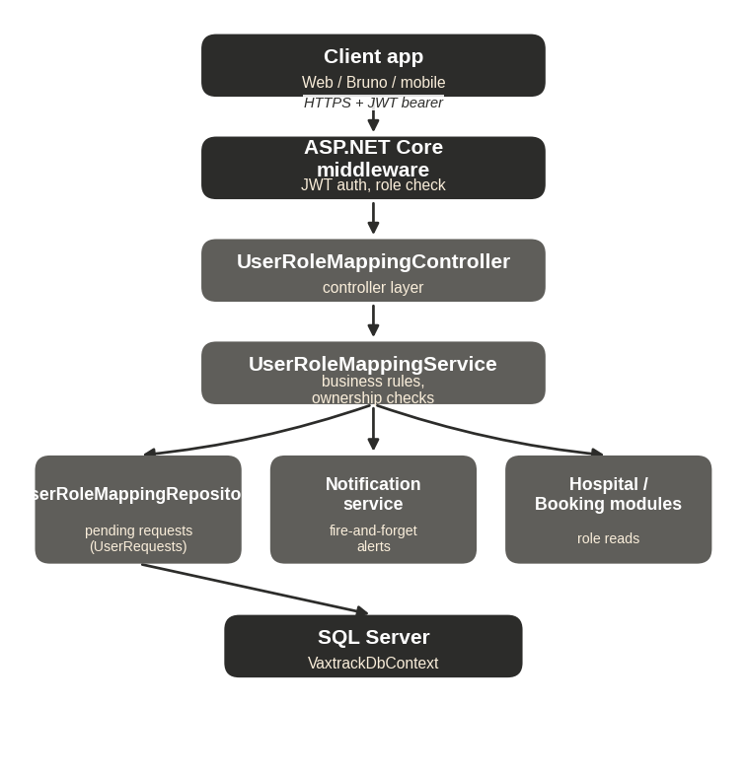
Figure 30. High-Level Design — Role & Access Requests module.
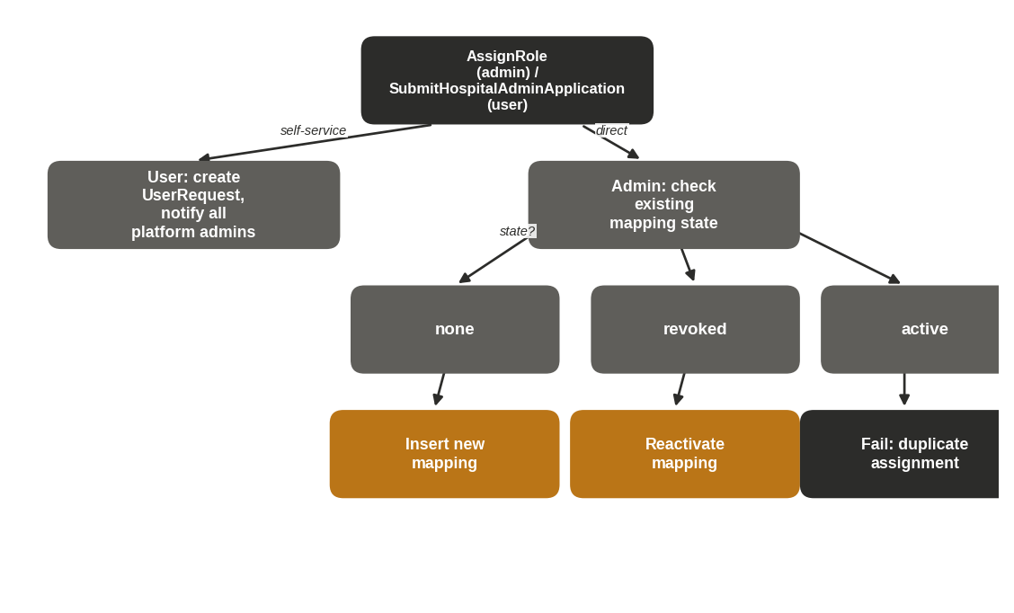
Figure 31. Low-Level Design — direct assignment vs. self-service application routing.

Key Flow — Hospital-Admin Self-Service Application, Approval, and Rejection (Figure 32)
1. A normal user submits POST /userrolemapping/submithospitaladminapplication with a target hospital and optional comment; a UserRequest (HospitalAdminApplication, Pending) is inserted and all platform admins are notified.
2. A platform admin reviews the queue via GET /userrolemapping/getpendingrequests, which returns both pending applications and pending account reactivations together.
3. On approval (PUT /.../approvehospitaladminapplication/{id}), the hospital-admin mapping is created or reactivated for the named hospital using the same reactivation-safe logic as direct assignment, and the applicant is notified.
4. On rejection (PUT /.../rejecthospitaladminapplication/{id}), the request is closed with a comment and the applicant is notified.

Endpoint Requirements
FR-ROLE-01 — Assign Role POST
FIELD | DETAIL
Endpoint | POST /api/vaxtrack/v1/userrolemapping/assignrole
Actor | Platform admin only
Behaviour: Directly grants a scoped role. If an active mapping already exists, the request is rejected as a duplicate; if a revoked mapping exists, it is reactivated in place; otherwise a new mapping is created.
Business Rules: BR-10.
FR-ROLE-02 — Revoke Role DELETE
FIELD | DETAIL
Endpoint | DELETE /api/vaxtrack/v1/userrolemapping/revokerole/{mappingId}
Actor | Platform admin only
Behaviour: Soft-revokes the mapping. Effect is immediate — the very next request relying on that role fails its scope check.
FR-ROLE-03 — Get User Roles GET
FIELD | DETAIL
Endpoint | GET /api/vaxtrack/v1/userrolemapping/getuserroles/{userUid}
Actor | That user or platform admin
Behaviour: Lets a user discover their own scoped role assignments — necessary since scoped roles are never encoded in the JWT itself.
FR-ROLE-04 — Get Users In Role GET
FIELD | DETAIL
Endpoint | GET /api/vaxtrack/v1/userrolemapping/getusersinrole/{roleTag}
Actor | Platform admin only
Behaviour: Optionally narrowed to a specific context id (e.g. one hospital's admins); omitted, returns every user holding that role tag in any scope.
FR-ROLE-05 — Is User In Role GET
FIELD | DETAIL
Endpoint | GET /api/vaxtrack/v1/userrolemapping/isuserinrole/{userUid}/{roleTag}
Actor | That user or platform admin
FR-ROLE-06 — Submit Hospital-Admin Application POST
FIELD | DETAIL
Endpoint | POST /api/vaxtrack/v1/userrolemapping/submithospitaladminapplication
Actor | Any authenticated user
Behaviour: Raises a pending request naming the target hospital and an optional comment, and notifies every platform admin.
FR-ROLE-07 — Approve / Reject Hospital-Admin Application PUT
FIELD | DETAIL
Endpoint | PUT /.../approvehospitaladminapplication/{requestId} | PUT /.../rejecthospitaladminapplication/{requestId}
Actor | Platform admin only
Behaviour: Approval creates (or reactivates) the underlying hospital-admin mapping for the named hospital using the same reactivation-safe logic as FR-ROLE-01; rejection simply closes the request with a comment. Either way, the applicant is notified.
Business Rules: BR-10.
FR-ROLE-08 — Get Pending Requests GET
FIELD | DETAIL
Endpoint | GET /api/vaxtrack/v1/userrolemapping/getpendingrequests
Actor | Platform admin only
Behaviour: Returns every pending self-service request — both hospital-admin applications and account reactivation requests (Section 5.1, FR-AUTH-05) — as a single review queue.

5.6 Module: Notifications
Notification
The in-app alert layer that surfaces every lifecycle decision back to the affected user
This module is deliberately thin and purely additive: every other module calls into it, fire-and-forget, whenever something happens that the affected user or platform admins should know about. A notification failure never fails the action that triggered it — it is written alongside, not inside, the underlying transaction (BR-23).
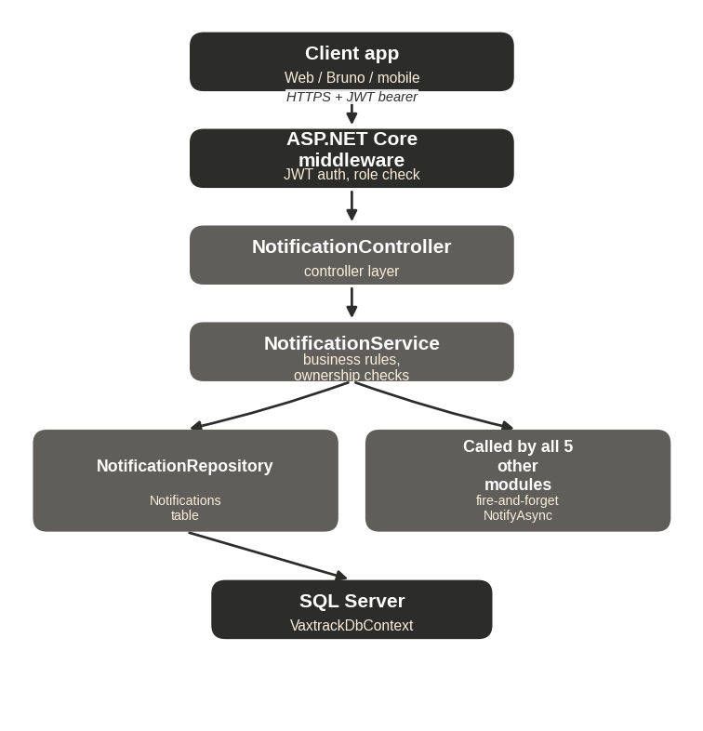
Figure 33. High-Level Design — Notification module and its callers.
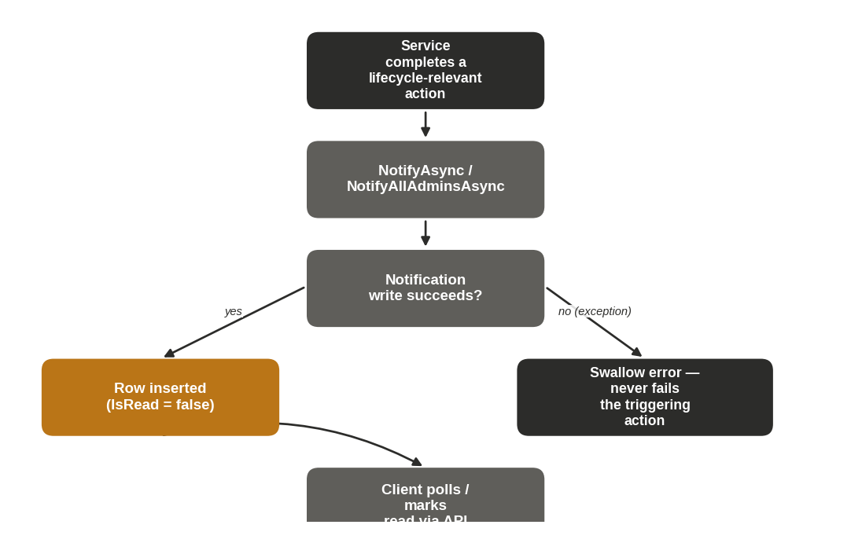
Figure 34. Low-Level Design — fire-and-forget delivery and read-state flow.

Key Flow — Notification Creation and Consumption (Figure 35)
1. Any service (Auth, User, Hospital, Booking, or RoleMapping) calls NotifyAsync(userUid, message, linkPath) or NotifyAllAdminsAsync(message, linkPath) after completing a lifecycle-relevant action.
2. NotificationService inserts one or more Notification rows (IsRead = false). This call never throws outward — a failure here does not fail the triggering action.
3. The client polls GET /notification/getmynotifications and GET /notification/getunreadcount to populate the notification list and the navigation-bar badge.
4. The user opens a notification and the client calls PUT /notification/markasread/{id} or /markallasread, setting IsRead = true.

Endpoint Requirements
FR-NOTIF-01 — Get My Notifications GET
FIELD | DETAIL
Endpoint | GET /api/vaxtrack/v1/notification/getmynotifications
Actor | Any authenticated user (self only)
FR-NOTIF-02 — Get Unread Count GET
FIELD | DETAIL
Endpoint | GET /api/vaxtrack/v1/notification/getunreadcount
Actor | Any authenticated user (self only)
Behaviour: Backs the unread-count badge in the frontend navigation bar.
FR-NOTIF-03 — Mark As Read PUT
FIELD | DETAIL
Endpoint | PUT /api/vaxtrack/v1/notification/markasread/{id}
Actor | Owner of the notification
FR-NOTIF-04 — Mark All As Read PUT
FIELD | DETAIL
Endpoint | PUT /api/vaxtrack/v1/notification/markallasread
Actor | Any authenticated user (self only)

6. Non-Functional Requirements
CATEGORY | REQUIREMENT
Security | All credentials are transmitted over HTTPS. Passwords are BCrypt-hashed, never stored or logged in plain text. JWTs are short-lived and are server-side revocable at logout. Every authorization decision (platform role and scoped role) is enforced server-side — the frontend never gates access on its own.
Auditability | Every state-changing action on a booking, hospital, or user is written to a permanent, append-only audit log capturing actor, action, timestamp, and (where applicable) a reason.
Data Retention | Deletion is soft throughout the platform — users, hospitals, bookings, and credentials are flagged inactive/removed, never physically erased, preserving full history for audit and dispute resolution.
Availability of Capacity Data | Hospital slot availability is updated synchronously and atomically with the booking action that consumes or releases it — no eventual-consistency window where capacity could be oversold.
Usability | Every account-lockout scenario (disabled account, forgotten password) has a documented, self-service recovery path that does not require manual database intervention.
Extensibility | Scoped roles are modelled generically (role tag + context id), so a future role beyond hospital-admin can be introduced without a schema change.
Observability | All service-layer errors are logged with the originating method name before being surfaced to the caller as a generic error, so failures are diagnosable without leaking internal detail to the client.

7. Business Rules
The rules below are cross-referenced by ID from the endpoint requirement cards in Section 5. They are the authoritative, consolidated statement of platform policy — where a business rule and a narrower FR description appear to differ, this section governs.
ID | RULE
BR-01 | A user cannot create a booking on behalf of another user — the authenticated caller's identity must match the booking's owner.
BR-02 | A user may hold at most one active booking at a time.
BR-03 | Dose 1 must be approved before Dose 2 can be booked.
BR-04 | Dose 2 may be booked at a different hospital than Dose 1.
BR-05 | A dose that has already been administered (completed) can never be cancelled or rejected.
BR-06 | Cancelling or rejecting a pending dose restores exactly one slot to the relevant hospital.
BR-07 | A hospital-admin may only approve or reject bookings at the hospital(s) they are scoped to.
BR-08 | A hospital's available slot count is always kept within the range [0, TotalSlots]; a hospital-admin may only update the hospital(s) they are scoped to.
BR-09 | Only a platform admin may perform a full-field administrative override of a booking, including marking a dose completed outside the normal approval flow.
BR-10 | Role assignment is reactivation-safe — granting a previously revoked role reuses the existing mapping row rather than creating a duplicate active row.
BR-11 | Permanently removing a hospital requires two-party confirmation: a platform admin initiates the unregister request, and the hospital's own hospital-admin (or the platform admin, if none is assigned) must separately authorize it with their own password.
BR-12 | Deleting a user, whether self-initiated or admin-initiated, cascades to soft-delete their active bookings (releasing slots), revoke their role mappings, and soft-delete their credentials.
BR-13 | A requested dose date/time must be in the future at the time of booking.
BR-14 | An email address must be unique across all active (non-deleted) accounts.
BR-15 | Changing a user's own email or password requires their current password, unless the caller is a platform admin.
BR-16 | A user's birthdate must be in the past at registration; age is computed once at registration and is not recalculated afterward.
BR-17 | A hospital-admin scoped role is always tied to exactly one hospital per mapping row; a user may hold the role for multiple hospitals via multiple independent rows.
BR-18 | A platform admin unconditionally satisfies any scoped-role check without a database lookup.
BR-19 | Authentication failure responses (wrong password, unknown email, or a disabled/deleted account) are identical in shape and message, to prevent account enumeration.
BR-20 | A disabled account cannot authenticate under any circumstance until a platform admin approves its reactivation.
BR-21 | A password-reset token is single-use and expires 15 minutes after issue.
BR-22 | A vaccination certificate exposes only beneficiary name, age, gender, hospitals, and completion dates — never contact details such as email, phone, or address.
BR-23 | A notification failure must never cause the triggering business action to fail; notification delivery is fire-and-forget.
BR-24 | Passwords are always stored as a BCrypt hash; plain text is never persisted.
BR-25 | Logging out revokes the current JWT server-side; a revoked token is rejected on every subsequent request even if it has not yet naturally expired.
BR-26 | Disabling a user account or a hospital requires the platform admin to supply a reason; the reason is retained in the audit trail.

8. Error Handling & Exception Scenarios
The platform uses a small, consistent set of outcomes across every endpoint. Business-rule violations and not-found conditions are reported as failures with a descriptive message; authorization failures are reported distinctly from validation failures so a client can tell "you're not allowed" apart from "that request doesn't make sense."
HTTP STATUS | MEANING | TYPICAL TRIGGER
200 / 201 / 204 | Success | Request completed; 201 for creation (with a Location header to the new resource), 204 for a successful action with no response body (e.g. delete, mark-as-read).
400 Bad Request | Validation failure | A supplied value fails a business-rule check the caller could reasonably fix — e.g. wrong password on Authorize Unregister, an invalid reason field.
403 Forbidden | Authorization failure | The caller is authenticated but does not own the target resource and does not hold the required platform or scoped role. Raised whenever a service-layer ownership or scope check fails.
404 Not Found | Resource state failure | Used narrowly — e.g. a certificate request for a booking that does not exist or is not yet vaccination-complete.
401 Unauthorized | Authentication failure | Missing, malformed, expired, or revoked JWT. Rejected by the authentication pipeline before any controller runs.
500 Internal Server Error | Generic / unexpected failure | Used deliberately for login and credential-related failures (BR-19, enumeration prevention) and as the catch-all for any unhandled service exception, which is always logged server-side first.
Why login failures return 500, not 401 — Returning a distinct status or message for "wrong password" versus "unknown email" versus "account disabled" would let an attacker enumerate registered emails or probe account status. VaxTrack deliberately collapses all three into the same generic failure at login (BR-19) — the one narrow exception is a disabled account, which surfaces a 403 with a machine-readable ACCOUNT_DISABLED code, but only after the password has already been verified, so a wrong-password guess cannot be used to fish for disabled accounts.

Cross-Cutting Exception Semantics
EXCEPTION | RESULTING RESPONSE
UnauthorizedAccessException (service layer) | Caught by the controller and converted to 403 Forbidden.
AccountDisabledException | Caught by AuthController and converted to 403 with { code: "ACCOUNT_DISABLED", message, reason }.
ArgumentException | Caught and converted to 400 Bad Request with the validation message.
Any other unhandled exception | Logged with the originating method name, then converted to a generic 500 response — internal detail is never returned to the client.

9. Assumptions & Constraints

9.1 Assumptions
- No outbound email service is integrated yet. Password-reset tokens are currently returned directly in the API response for development and test purposes; wiring up the stubbed email service to deliver them (and stripping them from the response) is a follow-on, not a redesign.
- A hospital's Dose 1 and Dose 2 slot number is caller-supplied; the platform does not perform server-side scheduling optimisation beyond enforcing capacity bounds.
- The platform does not enforce a minimum or maximum gap between a beneficiary's Dose 1 and Dose 2 dates.
- Profile picture storage is a path/URL string on the user record; the underlying file storage and CDN serving strategy is an infrastructure concern outside this specification.

9.2 Constraints
- Every authorization decision must be enforceable server-side without trusting any client-supplied role or identity claim beyond the validated JWT.
- No record may be physically deleted by the API — the soft-delete pattern (Section 6) applies uniformly across users, hospitals, bookings, and credentials.
- A hospital's available slot count must never fall outside [0, TotalSlots] under any sequence of concurrent booking operations.

10. Out of Scope
The following are explicitly not addressed by the current release of VaxTrack, and are not implied by any requirement in Section 5:
- Outbound email or SMS delivery of notifications, password-reset tokens, or certificates (the Notification module is in-app only; email is stubbed — see Section 9).
- Payment processing of any kind — the platform does not charge for bookings.
- Third-party identity provider (SSO/OAuth) login — authentication is first-party email/password only.
- Multi-language / localisation support.
- Native mobile applications (the API is client-agnostic and could support one, but none is delivered as part of this scope).
- Automated appointment scheduling/optimisation across hospitals (slot selection is manual, caller-driven).
- Hard deletion or GDPR-style permanent erasure of personal data (the platform uses soft-delete uniformly; a hard-erasure capability would need separate legal and technical review).

11. Glossary
TERM | MEANING
Active Booking | A booking whose vaccination is not yet fully completed and has not been fully cancelled/rejected — i.e. it still has an actionable dose.
Context Id | The value that narrows a scoped role to a specific entity — for hospital-admin, this is the target Hospital Id.
Dose Display Status | The server-computed, human-facing status of a dose (Pending / Completed / Cancelled / Rejected / Not Booked) derived from the underlying raw flags, so client screens never re-derive it themselves.
Reactivation-Safe | A write pattern where re-granting something previously revoked reuses the existing record instead of creating a duplicate.
Role Tag | The string identifier of a scoped role, e.g. hospital-admin.
Scope Check | A runtime lookup confirming a caller's scoped role applies to the specific entity being acted on.
Two-Party Confirmation | A safety pattern requiring two independent actors to agree before an irreversible action (hospital unregister) proceeds.
UserRequest | The generic pending-request record backing both account-reactivation requests and hospital-admin applications.

12. Appendix — Diagram Index
FIGURE | TITLE | LOCATION
1 | End-to-end functional flow | Section 3.3
2–5 | Use case diagrams (Account & Access, Booking & Vaccination, Hospital Management, Platform Administration) | Section 4.4
6–7 | Auth module — HLD, LLD | Section 5.1
8–11 | Auth module — key flows (registration, login, forgot/reset password, account reactivation) | Section 5.1
12–13 | User module — HLD, LLD | Section 5.2
14 | User module — key flow (profile self-service) | Section 5.2
15 | User module — state diagram (account lifecycle) | Section 5.2
16–17 | Hospital module — HLD, LLD | Section 5.3
18–20 | Hospital module — key flows (create/update, disable/reactivate, unregister) | Section 5.3
21 | Hospital module — state diagram (operational status lifecycle) | Section 5.3
22–23 | Booking module — HLD, LLD | Section 5.4
24–27 | Booking module — key flows (create/approve, Dose 2/completion, cancel/reject/edit/rebook, certificate) | Section 5.4
28–29 | Booking module — state diagrams (Dose 1, Dose 2 lifecycles) | Section 5.4
30–31 | Role & Access Requests module — HLD, LLD | Section 5.5
32 | Role & Access Requests module — key flow (hospital-admin application) | Section 5.5
33–34 | Notification module — HLD, LLD | Section 5.6
35 | Notification module — key flow | Section 5.6

13. Approval & Sign-off
This Functional Specification Document represents the complete, current business and functional behaviour of the VaxTrack v2.0.0 platform. It is submitted for stakeholder review with the intent that, once approved, it becomes the agreed baseline against which the delivered system — and any subsequent change request — is measured.
Reviewers are asked to confirm, specifically: that the business objectives (Section 2.2) and success criteria (Section 2.4) are correctly captured; that the roles and permissions matrix (Section 4.3) matches the intended access model; that no required capability is missing from Section 5; and that the business rules (Section 7) reflect actual policy rather than incidental implementation behaviour.
Next Steps — 1. Circulate to the distribution list in Document Control for review. 2. Hold a walkthrough / approval call to work through open questions section by section. 3. Record any agreed changes as a new revision in the Document Control history. 4. Upon sign-off below, this version becomes the baseline for the companion Architecture, Technical Specification, and Test Cases documents.
NAME | ROLE | SIGNATURE | DATE | DECISION
 | Project Sponsor / Business Stakeholder |  |  | ☐ Approved ☐ Changes Requested
 | Product / Delivery Lead |  |  | ☐ Approved ☐ Changes Requested
 | Engineering Lead |  |  | ☐ Approved ☐ Changes Requested
 | QA / Test Lead |  |  | ☐ Approved ☐ Changes Requested
VaxTrack — Functional Specification Document, Version 2.0.0, 08 July 2026. Confidential — prepared for internal stakeholder review.

